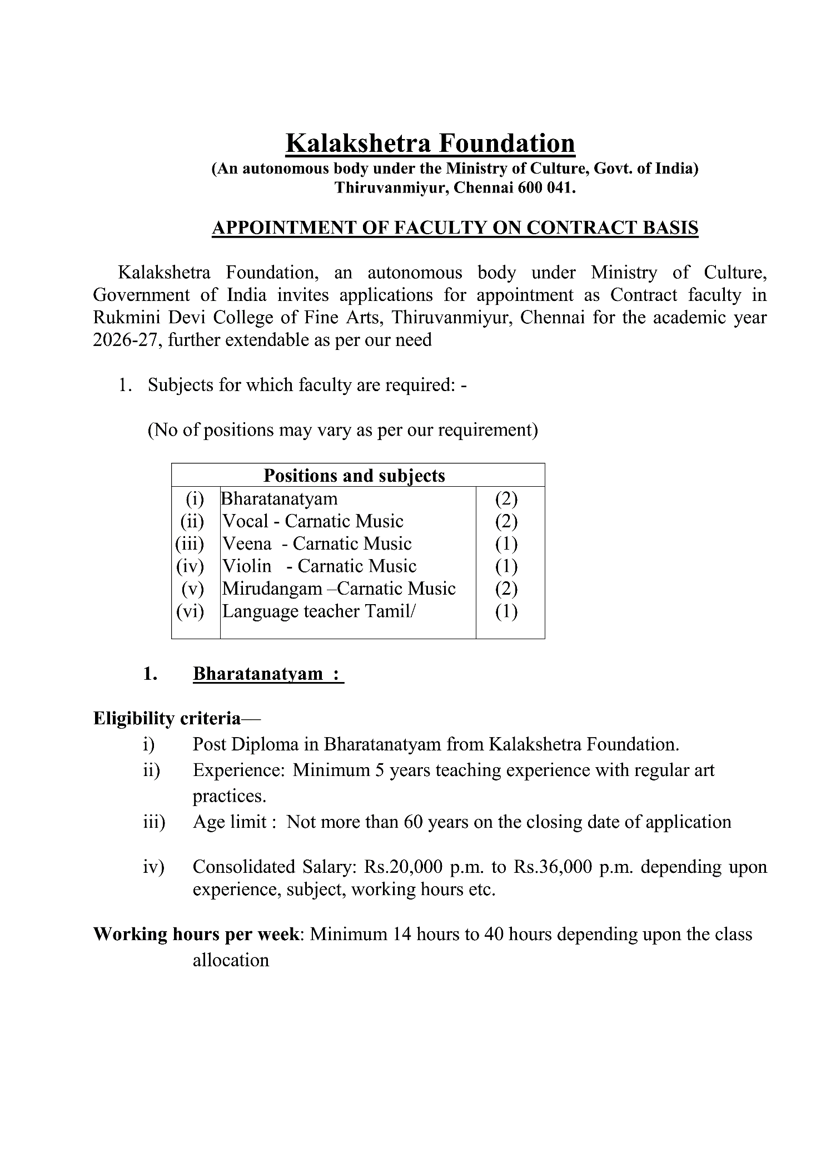
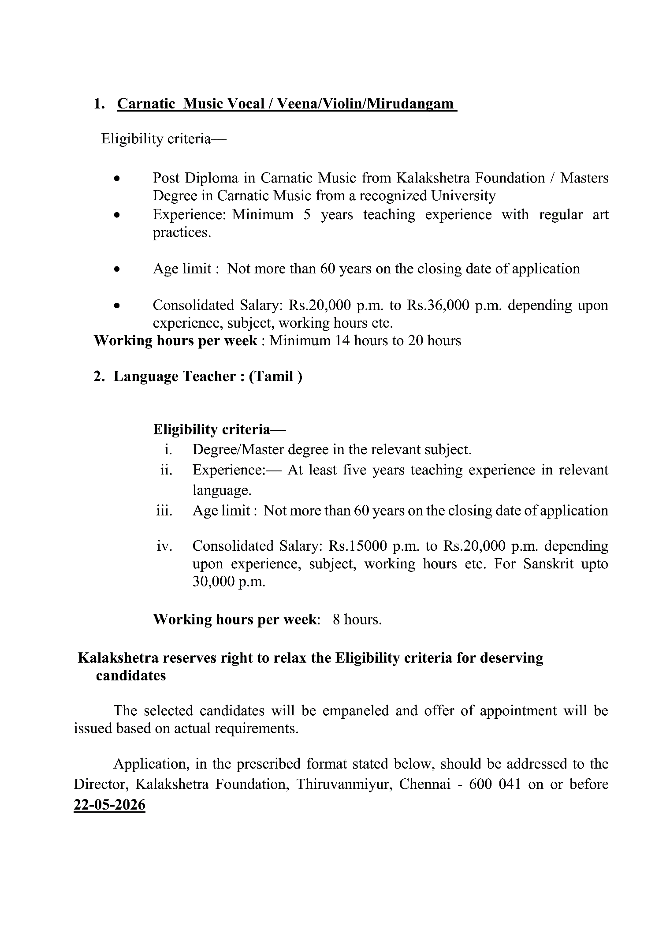

Kalakshetra Foundation
(An autonomous body under the Ministry of Culture, Govt. of India)
Thiruvanmiyur, Chennai 600 041.

(An Autonomous organization under the Ministry of Culture, Govt. of India)
(Rukmini Devi College of Fine Arts, Thiruvanmiyur, Chennai -41)

Post applied for the Faculty on contract for

- Applicant’s Name (in Block letter) | Pl paste a recent passport size photograph
- Mother’s name
- Father’s Name
- Address for communication

- Mobile No
- Email Address
- PAN Number (optional)
- Aadhar Number (optional)
- Date of Birth (DD/MM/YY)
Age as on closing date for submission of application
- Nationality
- Gender: (Male/Female/Others)
- Educational qualification:
S.No | Qualification | Board/University | Year of Passing | Percentage/CGPA

- Teaching Experience
Name of Institution | Designation | Nature of performance | Period of service
 |  |  | From | To

14. | Knowledge of Indian Languages |  | To Read | To Speak | To Write
15. How do you consider yourself suitable for this post?

16. Any other information, you wish to add:

17. I declare that all statements made in this application are true, complete and correct to the best of my knowledge and belief. I understand that in the event of any information being found suppressed/false or incorrect or ineligibility detected before or after the examination, my candidature/appointment is liable to be cancelled and my all claims for the recruitment will stand forfeited.
Place
Date
 |  | Signature of the Candidate

