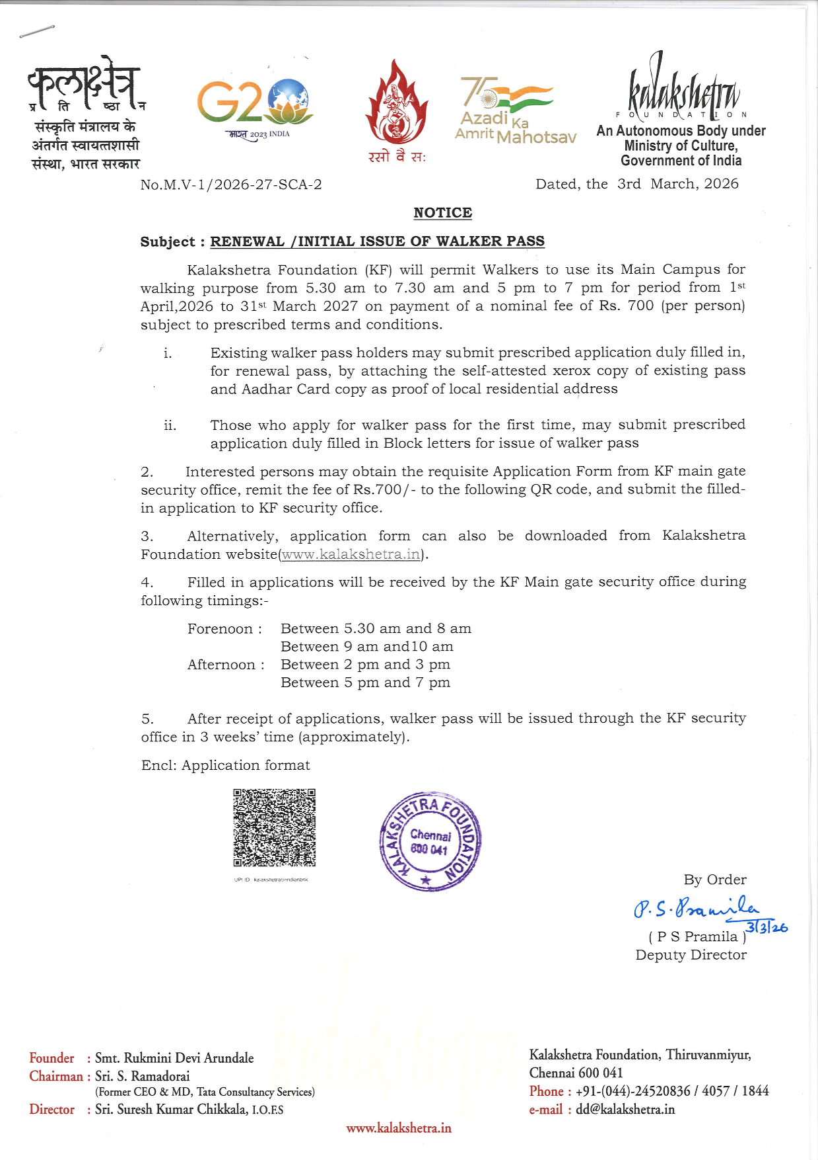


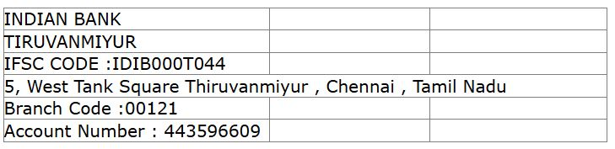
APPLICATION FOR WALKER PASS
 | KALAKSHETRA FOUNDATION  THIRUVANMIYUR CHENNAI -600041
 | ENTRY PASS FOR WALKER ONLY  Timings : 5.30 AM TO 07.30 AM & 5 PM TO 7 PM  (April,2026 to March,2027) |  |  |  | Affix latest PP size Photo  (for 1st time applicant)
Walker Fee  Cost of Pass |  | :  : | Rs. 625/- |  | Affix latest PP size Photo  (for 1st time applicant)
 |  | :  : | Rs. 75/- |  | Affix latest PP size Photo  (for 1st time applicant)
12-digit UPI Transaction No  & Date |  | :  : |  |  | Affix latest PP size Photo  (for 1st time applicant)
If you are existing walker pass holder:-  - Indicate the Existing Pass No. &  ii)attach copy of existing pass  iii)mention any change in address and mobile number against relevant column |  | : |  |  | Affix latest PP size Photo  (for 1st time applicant)
Gender |  | : |  |  | Affix latest PP size Photo  (for 1st time applicant)
Name |  | :
Blood Group |  | :
Mobile No. |  | :
Emergency Contact No. |  | :
Address |  | :
INSTRUCTIONS
1 | Entry from KF Main gate or KF Golden Gate. Walk in clockwise direction.
2 | Exit through KF Main gate/Golden Gate/Tashling gate
3 | Must wear the Pass visibly during the walking till exit.
4 | Must be in decent attire while walking
5 | Not allowed to bring pets
6 | Shall not tamper with KF properties/plants/flowers/trees, etc.
7 | Keep left, while walking. Walk on walking route only
8 | KF disowns responsibility for any injury or accident in KF campus.
9 | Not allowed Smoking/consuming liquor/use of mobile phone or transistor while walking
10 | KF reserves liberty to cancel the Pass at any time without assigning any reason
Note: Please attach xerox copy of your Aadhaar card or any Govt ID proof with address and photo.

Applicant’s Signature

