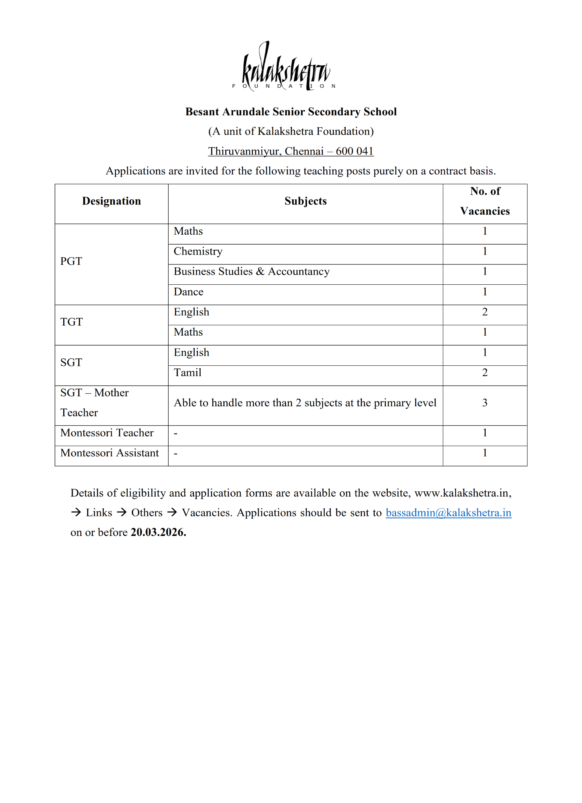

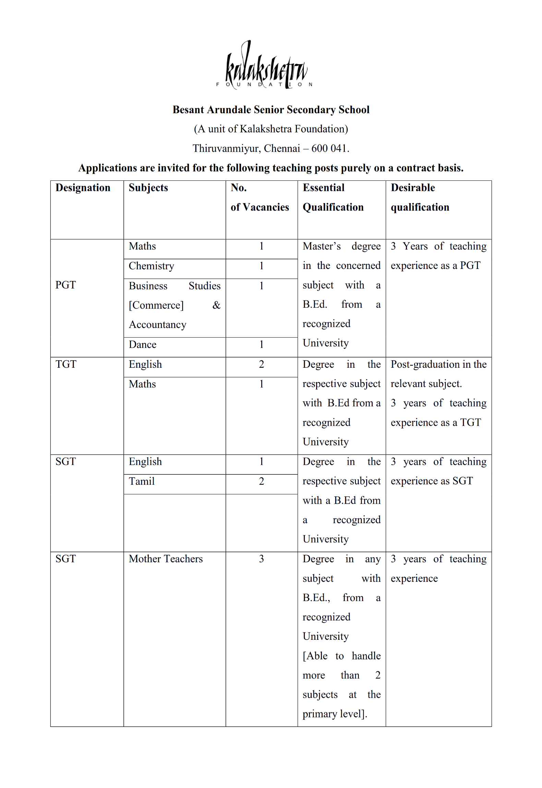
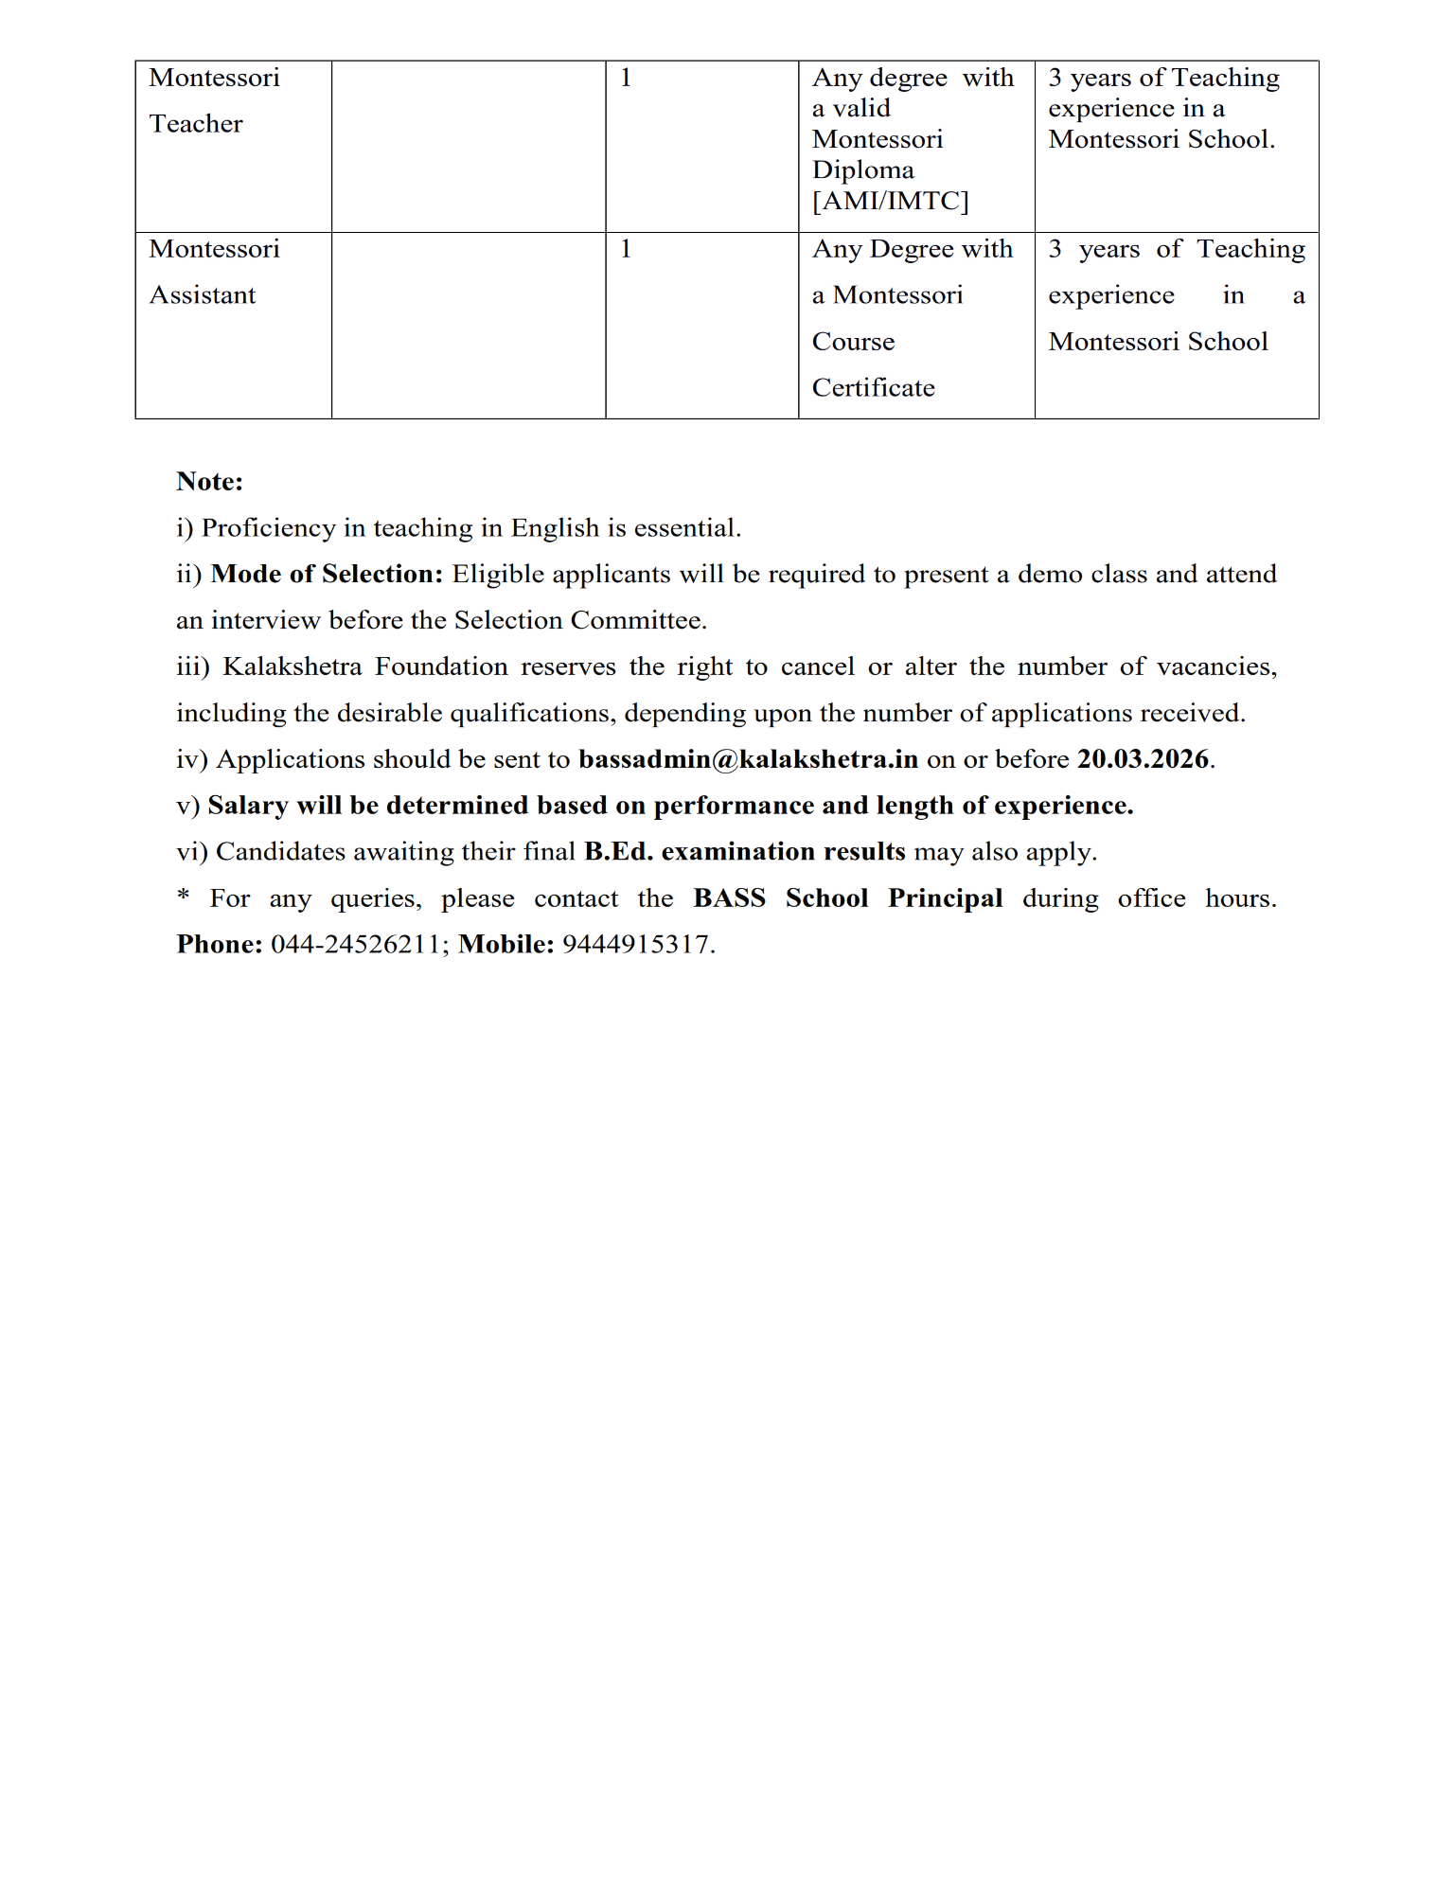



Pl paste a recent passport size photograph

Besant Arundale Senior Secondary School
Thiruvanmiyur, Chennai – 600 041
Application for the post of ______________________________ on a contract basis.
- Applicant’s Name (in Block letter)
- Mother’s name
- Father’s / Spouse Name
- Date of Birth (DD/MM/YY)
- Age as on 01.03.2026
- Gender
- Marital Status
- Address for communication

- Mobile Number
- Email Address
- Aadhar Number
- PAN Number
- Nationality
- Educational qualification: [Attach Self-Attested Copies of Mark Sheets and Certificates]
Qualification | Subject Specialization |  | Year of Passing |  | Percentage / CGPA |  | Board / University |  | Regular or Distance Education
Class X
Class XII
Graduation
Post Graduation
B.Ed.,
Other Qualification if any [Specify]
Other Qualification if any [Specify]
13. | Details of Teaching experience:
Name of the institution | Designation | Period of Service |  |  |  | Classes  Handled |  | Subjects  handled |  | Salary received per month
 |  | From |  | To

14. | Knowledge of Indian Languages | To read | To Speak | To Write

15. How do you consider yourself suitable for this post?

16. Any other information you wish to add:

17. I hereby declare that all the information given above are true, and correct to the best of my knowledge. I have attached self-attested copies of my testimonials in support of the entries made above. In the event of any information, being found suppressed/false or incorrect or ineligibility detected before or after the interview, my candidature/appointment is liable to be cancelled and my all claims for the recruitment will stand forfeited. I also understand that in the case of selection, the appointment is purely on a contract or temporary basis with no opportunity/claim for a regular appointment.
Place: |  | Signature:
Date: |  | Name:
*Enclose a separate sheet if the space above is insufficient.

